William Pearson

No Fixed Bias: The First steps

Machine Learning and Adaptive Computing

2001

Abstract

Whilst there has been significant exploration of evolutionary systems based around Genetic Algorithms, Evolutionary Programming and Evolutionary Strategies there has not been much interest in the use of a Tierra-like system from artificial life in the solving of problems. It is argued within that, because of the flexibility possible in these sorts of systems that have internally defined (or endogenous) variation, they should be investigated. Presented herein is also a Tierra-like system that should be suited to having the programs written with endogenous variation and some initial experiments to determine whether the system acts as expected and investigate some variations in the system. The system is based on the assumption that one mediocre good general search is not desirable in a complex dynamic environment, rather many specialised searches and that some way to find different search modules and some way to improve the method of finding different search modules would be preferable.

TAble OF COnTENTS

1. Introduction 4
2. Literary Review 5
2.0 Artificial Life 7
2.1 Evolutionary Computation 9
3. Theoretical and Philosophical thoug 12
3.0 General problem solving and the No Free Lunch theorem 12
3.1 A Different View of Evolutionary Computation 14
3.2 Comparison with Pushpop 18
3.3 Mathematical Description of a form of No fixed bias search 19
3.4 Levels of Learning 22
3.5 Problems with Some current approaches to intelligence 24
3.5 The trouble with non-descriptive theories 27
3.6 Epistemology 27
4 Design of EGVM 29
4.1 Evolutionarily Guided Virtual Machine 29
5 Results 37
5.0 Experimental Design 37
5.1 Initial Experiments 38
5.3 Test of other types of Mutation 46
5.3 Various Different Utility Schemes 53
6.0 Conclusions 55
References 57
Appendix I 60
Appendix II 61
Appendix III 62

1. Introduction

It has become a trend recently in AI to ask for big ideas and different ways of looking at things, from Seymour Papert (Web 2001) to Rodney Brook (Brooks 2001) and Rob Smith (to be published), “something is missing” is the call. So it can only be expected that young naïve researchers will come along and try to think outside the box of conventional AI. I am one of those and my ingredient to add to the recipe that is artificial intelligence is of a semi-philosophical/semi-biological nature. It is to do with creativity and search, and how minds can be supple as they are. It is argued here that to get very flexible and creative computer systems a paradigm shift will be needed in the way we program computers. Then a system is presented that is based on looking at evolution in a different way than the mainstream, instead of generalising from nature in how evolution works with things like crossover and sexual reproduction, I try to make the case that evolution should be explored as a possibility for what happens in the mind and the full Larmarckianism that this entails. In order to try and verify these ideas similar systems should be explored in evolutionary computation.
The systems this sort of thinking suggest are evolving systems where groups of cooperating and competing programs solve problems and are rewarded for doing well. This reward allows the programs to survive within the system and therefore differential survival is entailed and so evolution. The programs within the system should create the majority of variation in the programs of the system. This can be done by copying ideas from outside as well as creating new elements internally.
- In section 2 previous work in evolutionary computation and
- In section 3 the philosophical reasoning for this type of system is given and a brief comparison with some other models of the mind is given.
- In section 4 the system is described and reasoning given for some of the decisions taken whilst designing the system.
- In section 5 the results and analysis from three sets of experiments are presented that investigate the working of the system.
- In section 6 the work is discussed in more details and ideas for further work based on what has been so far achieved are given.

2. Literary REview

Before giving a brief review of evolutionary computing I shall illustrate how lots of searches can be seen to have something in common with evolution.

As noted by Darwin in regard to evolution there are three features of a system that allow it to evolve: Variation of heritable features, selection of some of the good features and retention over time of some of those features. This categorisation of elements can be applied to many of the search algorithms that have been created not just the ones that use Genes as their inspiration. To give you an example from a search that some would say is far away from genetic algorithms, I shall use Backprop, which is a common method for searching the space of weights for a neural network. Backprop which applies an update rule based on the error of the output compared to the desired output, can be said to search the space of weights by 1) varying the weights using the gradients of the error, 2) always selecting the varied weights and 3) the weights are related to the previous weight retaining some of the information. The only mainstream search algorithm that I can think of that fails these three criteria is randomized search that picks a random search point each time, this does not use heritable features. Apart from this case these three things, variation, selection and inheritance contribute to the bias of the searching system.

The main thing that separates evolutionary algorithms from other search algorithms is the population and the interaction between members of the population through selection and crossover. This enables them to search discontinuous and complex search surfaces that a search with only a single search point tends to have trouble with. The schema theorem suggested by Holland (Holland 1979) explains why crossover is useful in problems where the fitness of the sub schema have some relationship to the fitness of the individual they make up. The schema theorem suggests that if the fitness of the schema has some relationship to the fitness of other schema made of the same sub-schema then crossover of fit schema should create different schema with fitness related to and possibly better than the previous two.

However not all problems have this phenomenon so in order to get adequate performance for different problems knowledge about the problem has to be embodied in the operators and the representation for a specific problem. A statistical explanation for why this should be has been given by the No Free Lunch Theorems.

No free lunch theorems, which give some idea of how bias affects search over the space of all problems, were presented by Wolpert & Macready (1995), although a more natural description was given by Culberson (1996) where he redevelops these ideas, using the adversary metaphor. This is where an adversary that makes up the cost function in order to make the search algorithm perform badly, represents the problem. The example of the adversary in the technical report is one that randomly selects the next function value if it has not been seen before. This means that any search algorithm that makes assumptions about the topology of the search landscape will only make the correct assumptions by random chance, because any assumptions will be false due to the random nature of the next draw. Running the adversary an infinite number of times will produce all possible functions, and on average no algorithm will do any better than any other. The No free lunch theorems have been summed up (Wolpert & Macready 1995) in this statement “any algorithm performs only as well as the knowledge concerning the cost function put into the cost algorithm”.
My proposal can be seen as trying to extract knowledge from the cost function in an online fashion to put into the cost algorithm. This contrasts with the standard way of humans having to extract the knowledge from the cost function and then instil this knowledge into an algorithm. However as the system only starts with minimal knowledge it might be slow to arrive at the correct searching algorithm.

2.0 Artificial Life

Artificial Life is the endeavour to create life-like systems, physical and computational, so that they can be studied and compared with biological life. It is relevant to this dissertation because there has been work on evolutionary systems and one of them, Tierra, shares lots of similarities with my system in aim and philosophy if not architecture and methods of variation.

Tierra (Ray 1991) was the first of a series of similar systems that hoped to achieve something they call open-ended evolution. This is defined as the ability to create unbounded complexity via evolution. The system was designed to create an explosion of diversity as seen in the pre-Cambrian era. This system was a group of programs within a virtual machine, these programs replicating and competing for survival. As such it was not designed to solve problems, although it has been suggested that it could. It is noteworthy in the fact it was the first system to show stable evolution of machine code. Another system had evolution Venus (Rasmussen et al 1990), but not stability. Tierra managed to overcome this problem by introducing the notion of a virtual organism and saying that the memory of the individual was protected. The initial individuals are hand coded and the variation is introduced by external bit flipping and copying errors at least to start with. There was evidence that some variation was introduced by parasites that were sloppy copiers. This external variation means that in order to be able to explore different forms of variation, they would have to use this form of mutation to create protection against itself and create other forms of variation before they can begin to search the space of searches, this may be too tall an order at the moment. The programs also have limited communication and no control over who can access their information. In order to remove individuals from the virtual machine so that the entire space is not filled there was a reaper in the system that removed individuals on a FIFO basis. There has also been work (Bedau et al 1997) suggesting that Tierra like systems are qualitatively different from evolution in the real world, in that they do not show unbounded evolutionary activity.

Avida (Adami & Brown 1995) is based on this style of system. The main difference is that it is based on a two dimensional cellular organisation of organisms rather than contiguous blocks. It has been used for solving the problem of adding two numbers together. It showed a significant difference in how quickly the problem was solved that was dependent on the mutation rate in the system. This suggests that it had not escaped the bias imposed upon it from the external mutations. The utility function used for this project was very helpful in that it rewarded partial solutions to the problem in order to allow multiple changes to the genome be made.

Also note worthy although of a different philosophy from the above is Geb by Channon(1998) he argues that a fixed fitness function should not be used to try and evolve intelligent life, because it will not allow the requisite emergence to take place. I however believe if non-fixed functions are used such as those that involve feedback from a very rich environment or a human are variable enough for emergence beyond that which was initially programmed into the system.

2.1 Evolutionary Computation

Self-Adaptation

Self-adaptive mutation has a long history in evolutionary computation with Evolutionary Strategies (Rechenberg 1973) and Evolutionary Programming (Fogel 1966) leading the field. The varieties of adaptation of the mutation rate that have been used include, but are not limited to the 1:5 success rule (Rechenberg 1973), and the use of internal parameters to specify the mutation rate σ-Self Adaptation (Schwefel 1974, 1995). Beyer (1995) suggests that other methods other than lognormal mutation rule for σSA can be used successfully. Another type of classification that has been created for self-adaptation, these are exogenous and endogenous. Exogenous means that the way that the mutation rate is varied is applied externally, endogenous systems change their own rate.

One interesting idea from evolutionary computation that fits in with the idea of not having a fixed search and also having many specialised searches rather than one large search is COMA (Smith to be published 2003). This is a Memetic algorithm, which is a genetic algorithm that includes a local search, which works in conjunction with the genetic algorithm. What is interesting about COMA is that the local search is encoded within separate population of evolving individuals and is altered by the genetic algorithm to search the space of variation operators.

Pushpop (Spector 2001) is a recent development in Genetic Programming(GP) looking at an interesting way of doing the evolution instead of the normal mutation and recombination. The programs were randomly created as in standard GP, the difference being that they had a stack with which they could access with a copy of themselves. This stack then becomes the offspring of the next generation. This meant they could alter the offspring in whatever way they want and along with some other functions find ways of recombining, could find their own ways to vary themselves. The selection is still a standard Tournament selection method, and suffers from premature convergence where the programs stop mutating their offspring. One of the big advantages of this system is that it does not require seeding with programs. It would be interesting to see whether that could be achieved in a freer system without fixed selection and if any advantages stem from this.

Learning classifier systems (Holland 75) are the systems that have so far been the most successful at solving dynamic learning problems. They are based on a Genetic Algorithms (GA) where the individuals co-operate to form a strategy for a use in a reinforcement learning paradigm. Michigan style classifiers that evaluate individual rules have an advantage over canonical GP because they separate the problem into sub-problems, which can be solved separately, and these solution(s) may still be useful if the world changes. This is because an individual is single state change rule and rules are linked together by passing some of the fitness of an individual to others that help that individual reach the goal state by acting in different states. However this interaction between individuals is strictly regulated. Although some people have worked on self-adaptation of the parameters that control this (Hurst & Bull 2000), these still introduce bias into the system towards certain environments.

There is also two current “Real Ai” projects on the Internet that propose something along similar lines to my system, they both have incorporated the idea of recursive self-improving, where the program alters itself to make itself better. They are both explicitly goal orientated with goals alterable by the system, which could make them be inherently unstable without outside interference to keep it towards certain goals. One is based on the ideas of “SeedAi” and “FriendlyAi” (Yudowsky) based on the belief that the goal system will act to preserve itself, the other Novamente (Goertzel) is based on the belief that the goal system will change but into other interesting and useful forms. Neither of them has been tested yet.

In summary the systems here can be seen to have two components. One, the variation function can be self-determined and so the next generation created entirely by the previous, there should be no fixed bias due to this. The other way is the selection function, this comes down to how much an individual can affect the survivability of the other individuals. If the survivability of an individual is entirely due to the actions of the other individuals then there should be no bias from this.
As a caveat it should be noted that there have been some problems with evolutionary algorithms that have adaptation of the variation operator prematurely converging. This has been shown to be a problem for the 1:5 rule in ES if unsuitable meta-variation rates are chosen by Rudolph (2001). Smith (tbp 2003) has model based and empirically based evidence and analysis to show how endogenous version of a Self-Adaptive GA has a tendency to get stuck close to the optimum compared to the exogenous version.

3. Theoretical and Philosophical THOUGHTs

3.0 General problem solving and the No Free Lunch theorem

If we are general problem solvers as shown by our ability to solve many problems with no hard limitations, how does this tie in with the no free lunch theorems of search introduced by Wolpert and Macready? It has been discussed often with respect to evolution but I haven’t come across a discussion comparing it to human intellect. Concisely put the No Free Lunch theorem states that, over all problems each algorithm will do on average as well as any other. This is because each algorithm is biased towards certain problems due to the way it works. How then do humans show the ability to change the problems they are good at solving? Also what causes the difference between peoples learning ability? Perhaps we have a module that can change the way we think about problems. Does this module stay fixed or can it also change over time? Perhaps there is yet a higher-level version. Somehow I don’t think so. I propose a way that the bias can change over time without such monolithic potentially infinitely regressive structures.

To be free of bias, over the long term, requires that no part of the system be problem solver to be constant, apart from some mechanism to make sure it solves certain problems. How can this be reconciled with normal search mechanisms such as Genetic Programming where significant parts of the program are constant?

In order to clarify my position, I am going to slightly change the question posed by Arthur Samuel(1950) and quoted in Genetic Programming by Koza (1990).

“How can computers learn to solve problems without being explicitly programmed? In other words, how can computers be made to do what is needed, without being told exactly how to do it?”

In the light of the No Free Lunch theorem of search, in which the authors suggest that we should:

“start with the given f, (cost function) determine certain salient features of it, and then construct a search algorithm, a₁ specifically tailored to match those features.”

I propose a new sub-question, that I think needs answering to truly answer the first question:
“How can computers be made to create a reasonable search algorithm for a certain problem by incoperating information about a problem? In other words, how can programs finally be free of the bias their creators programmed into them when trying to solve problems?”

My answer to this question is a form of evolution based on Artificial Life techniques. In the following sections I try to show how it could do arbitrary levels of learning and also adapt to different types of learning. However first I will try and highlight how thinking about evolution has been influenced by biology and ask whether this is appropriate for evolutionary computation.

3.1 A Different View of evolutionary computation

Evolution is a very strong philosophical concept and before looking for mysterious other properties or other systems it should be investigated to see if evolutionary computation has missed any important permutations of it. As we only have one long-term example of very creative evolution it is important not to rely too heavily on that for inspiration, because of the statistical dangers of generalising from one example. It is argued here that there is lots of scope within evolutionary computation to look at different ways in which the variation operators can be defined and altered within the system including ways that allow Lamarckian learning and adaptive signals.

A lot of evolutionary computation work (apart from memetic algorithms) unconsciously or consciously uses the central dogma of genetics: that is that information can only flow from the genotype to the phenotype. This can be seen by the fact that for the most part the genotype cannot change itself following information from the environment; external operators always change them. This means it cannot be tried out except by creating a new individual. This has not been justified within computation compared to its justification within biology, where the massive non-linearities created by the RNA to protein transformation and the self-organisation of the multi-cellular organism. This dogma is also used as the justification for the fact that most changes to the genome are deleterious because it is unknown what effect a certain mutation will have.

There are two effects of this dogma. One is that the plasticity in the phenotype cannot be translated to the genotype, the smith’s strength being transmitted to the son. The other less often argued about, is the phenotype affecting the next genotype through knowledge gained during its life. For example the proverbial giraffe stretching his neck could decide to modify his gametes by altering the section that codes for his vertebrae to make his children’s necks longer. Both are impossible due to the amazing non-linearities that occur at the protein folding stage and the embryology stage. However does the same have to apply to evolutionary computing? What would an evolutionary system that was not constrained in this way look like? Memetic algorithms are an attempt to get around the first block by performing a bit of local search and then encoding the results back into the genotype, however the local search is not defined by the genotype and so is still biased towards a certain problem. The main difference in my idea compared to traditional EC, is the scope of what I advocate should be modifiable or creatable by the programs. In this sense I am advocating going closer to biology as there are no external constraints on what the molecules do to each other, apart from those constrained by how the molecules are created from the elements.
I think that I should make it clear that what I am saying is not an attack on Neo-Darwinism in biology it is just that Neo-Darwinism should not be automatically transferred across to evolutionary computation. So what do I think that evolutionary computation can gain from realising its differences with biological evolution? This is covered in the next but one section the selection of methods of variation.

Since it seems that we can create programs that are a bit like parts of our minds using easily modifiable programs, where intelligent variation can be used, it seems unjustified that evolutionary computation should be treated exactly the same as biological evolution in this regard. There is little justification for the ideas that information should just flow from the phenotype to the genotype and that mutations or changes to the phenotype are always more likely to be deleterious than not in evolutionary computation.

If biological evolution is only seen as a ratchet effect that is preserving variation created by external sources then it has little to say about sources of variation that can be prevented by action of the genes such as transposons, viral genetic transfer and even sexual reproduction. Indeed it has nothing to say about Genetic Engineering. If you allow however that evolution can create organisms that act towards goals e.g. phototaxis, why could not one of the goals be the improvement of their offspring (taking into consideration the genotype->phenotype mapping)?

Selection of Methods of Variation
We are familiar with knowledge about the environment being extracted by variation and selection and retention. It has also been postulated that evolvability, the ease of evolution of the genetic code, (Dawkins 1989) has evolved, which suggests that the current genotype-phenotype mapping has been created by selection between different genotype to phenotype mappings to find the one that has the evolvable features. However for systems that do not have the central dogma of embryology there is another possible for this meta-variation that allows great possibilities that are similar to the evolution of evolvability but with far greater possibilities for intelligent change.

This I call the meta-variation, where different ways of varying programs in the population are competing against each other. This competition improves the way that modules are created in relation to the environment at the time.

This is not a new concept in computational circles, yet it may be able to explain how the methods of creativity, in minds, that are due more to directed variation than pure selection, may have come about by a selective process. This also allows this evolution of variation to have been due to the much quicker evolution of the mind rather than being created in the biologically evolved substrate. This view that the mind may perform selection of variation may mollify some of the critics of a purely naturalistic reason for creativity and would allow nurture a way of influencing creativity and inventiveness.
Some previous works also point out that you do not want one mediocre good general search you want lots of very good specialised searching modules and some way to find different searching mechanisms and some way to improve the way you find different searching modules.

Some examples of previous work that includes the idea of different searches are Variable Neighbourhood Search (Mladenovic N. and Hansen, P, 2001) which systematically uses a series of different neighbourhoods to move in, in order to minimise getting stuck in local minima and thus maximise the space searched, and the Co-evolution of neighbourhood searches in Memetic Algorithms (COMA) (Smith tbp 2003) which as described earlier searches through the space of co-evolving search metrics. There is also Hyper Heuristics (P. Cowling et Al. 2001) that applies a series of low-level heuristics to the problem; a Hyper Heuristic or higher level heuristic guides this application in order to have flexibility over the types of problems the algorithm can cope with, and so reducing the bias once a reasonable heuristic(s) has been chosen. These all generally have a fixed hyperheursitic in that the way they vary there heuristics doesn’t change.

On the subject of whether the meta-variation is internally defined within the system or a biological externality will probably cause some debate. At this point I believe that the majority of it is endogenous. A possible conscious example of this is logic being used to craft the finer points of logical thinking which is suggestive of a sort of temporal recursion. I do not rule out biologically fixed systems that play small parts around the beginning, but are not the main driving force behind the development of our minds.

Also if the variation is internally defined then the system has the possibility of getting knowledge about how the variation of meta-variation should proceed, if such knowledge is extant within the environment.

This brings up the point that only evolution can only work with what the environment gives it; it cannot create complexity from thin air. So systems that attempt to learn should be embedded an environment with very similar rules to the environment they going to be used in, if pre-use learning is used.

Although meta-variation may seems like a Lamarckian model it has some relation to Darwinian theory as the different methods of variation are selected, they are not imprinted, unless of course higher levels of meta-variation are at work (see the next but one Section on Levels of Learning). However there is always Darwinian selection at the lowest level of learning, i.e. the selection of better programs because of their survival ability.

However there is in not much evidence that evolution of variation has been thought of outside of evolutionary computation (see section 2), due no doubt to the constraints imposed by the non-linearities.

3.2 Comparison with Pushpop
Here it has been picked up and extended by a system that has lots in common with the one being designed here, Pushpop, (Lee Spector 2001). Lee Spector also calls the evolution of variation, auto-constructive evolution as the programs automatically construct their own reproduction and diversification. The main similarity is that parent has full control over what variation is placed on the offspring. The differences in the philosophy generally come from three areas; how the individuals interact, what the applicability of the work to different fields is, his concentrating on biological evolution and mine on mental evolution, and also related to this, how the program is initialised.

Due to Pushpop being based on Genetic Programming it prevents interactions between individuals apart from the copying of information from one individual to another. My philosophy suggested that certain interactions between individuals might allow them to co-operate in the solving of certain types of problems (as is done in learning classifier systems and similar to agent based models of the mind). Also it allows different rates of creation and reproduction that might be more similar to the mental processes we know.

The second point of difference in my philosophy compared to his is that, due to the central dogma of embryology, the evolution of variation has less to say about biological evolution compared to what it may say about Lamarckian mental evolution and the trial and error of behaviour. Having said that the biologists will have to reckon in the future with human meddling with evolution and changing it quickly and this may not quite fit their models. Or will biologists give up on human evolution when genetic engineering has come in and muddied the water. Personally any full model of biological evolution should take this into account, as this is part of nature.

The third point of difference is what the starting programs should be, according to the genetic programming philosophy completely random programs are used. As there is thought to be some innate programs in the brain such as the ability to imprint and other natal reflexes it would seem that it is possible for biological evolution to create initial starting programs or patterns in the brain.

However as has been noted there can be variation of meta-variation. The next section shows how a free evolutionary system could be able to be more flexible than one with exogenous or strictly hierarchical search.

3.3 Mathematical Description of a form of No fixed bias search

These are initial thoughts that will be refined as experimentation occurs. Note however that although the system I am designing can work like this although is doesn’t have to, if this is not the best way of adapting to the environment. They are based on the idea that no fixed bias search requires a second order description. I took second order from logic, where it refers to functions or predicates acting on other functions or predicates. W is the symbol I use to indicate that the world state can be used to influence the search however I omit it in the discussion below for clarity as all functions can depend upon the world state.

S_{t+1} = S_{t} (S_{t}, W_{t}) and P_{t+1} = S_{t} (P_{t}, W_{t})

This is the best description I have found so far of a system with some of the characteristics of no fixed bias. It basically says the search method at time t+1 will be equal to the result of the search method at time t applied to itself. And that the solution program (P) at t+1 will be equal to the search at t applied to the solution program at time t. As a self-adaptive system it is endogenous meaning that it affects itself. All the variables are assumed to be programs.

Another search method with similar dynamics would be: -
S_{t+1} = S₀ (S_{t}, W_{t}) and P_{t+1} = S_{t} (P_{t}, W_{t})
This is a simple Learning II system as described in the next section.
This system is said to be exogenous, which means that the search is evolved by external action. What would be the operational differences between these systems?
It is illuminating to imagine that the search is at a local optimum for the current search mechanism. Now would they be stuck? Not necessarily it depends on what the adjacent search landscapes look like, if they are better or the same (either not a maxima or a wider or same maxima) then the search could move this way and possibly find a better value by moving around the space of searching. This would be the same for both formulae as they can both search the space of searching. However the initial formula has the added advantage that when the search method is changed it also changes the search landscape of the search. This means that a second order search landscape that looked like a maxima using that S_{t} may not be a maxima in S_{t+1}.

A real world example of second order searching might be in order. Ugh the cave man and Blagh his brother are trying to catch dinner; they have their stone tools. They decide to use their flint axes and other tools to cut down a tree and mine some copper and tin ore and makes a series of bronze tools (such as arrows and spears) these they use to catch their food. Now comes the point to create some new tools after this, Ugh decides to use his new bronze tools such as axe and adze and hammer to create iron tools. Blagh sticks to his stone tools to try and create iron tools (he isn’t so successful). As you might have guessed Blagh is the second equation and Ugh is the first. So Blagh is limited to what can be created with his stone tools whereas Ugh can move on to any other type of tools in the series. They have a slow cousin called Clog who just uses stone tools. This is equivalent to most modern search methods (note though they may start off with steel tools or even electronic tools, they can never get any better). Also note however that in the system there is no such thing as a Caveman, that is, there is no constant.

You could go on to another system such as
S_{t+1} = S₀ (S_{t}, W_{t}) and S2_{t+1} = S_{t} (S2_{t}, W_{t}) and P_{t+1} = S2_{t} (P_{t}, W_{t})
And so on; with each search adding more flexibility, however it would be more limited than the original idea, due to the fact that it might not have a good bias for changing the search, it would also be unable to search differently for different points. However these systems have the advantage that evolution is forced upon them, this means that if the exact optimal is required of the system then they may be more effective, as shown by Smith (in preparation).

This is similar to what is proposed in Society of Mind (Minsky 1986, pg 59) for b-brains etc that regulate learning. This would allow stone tools to make bronze tools to search the space of arrows and other food gathering equipment.

3.4 Levels of Learning

It has often been remarked that humans can learn how to learn for example in Society of Mind (Minsky 1986, pg 59) with b-brains etc that regulate learning and change how we learn to learn.

A useful classification of types of learning has been given by Bateson (1972). Here he defines a hierarchy of learning from Learning I; the learning of facts from selection of alternatives and Learning II; a change in the process of Learning I or in other words selecting from different alternative methods of Learning I. And Learning III a change in the process of Learning II etc… He goes on to clarify that this simplified hierarchy is not be a full description and more interactions between levels could happen.

At this point I would like to present the notion of a Learning R system. That is a system that can exhibit all levels of learning and can make transitions between levels of learning.

The system I will demonstrate the idea of a Learning R system is not necessarily the only system that could have the Learning R property but it is the type that I shall investigate. Imagine a series of programs that reproduce themselves and compete for existence in environment where they are given reinforcement for a task and this reinforcement allows some programs to survive in favour of others. Now if the environment does not change the programs they are incapable of learning. However if they have within themselves a section of code, which we shall call LI, that changes their offspring in a blind manner there is a chance for improvement.

Diagram 1.

LI
S
Information

Such a program would evolve much as we understand biological evolution. However if one the random changes cause the offspring of the program to change one that looks like this.
Diagram 2.

LII
S
LI
Information

As we are doing randomised search through the space of programs this is possible.
Diagram 2 shows a system capable of Learning II in a semi-random way with LI being changed in a semi-random fashion however LI would change S in a non-blind way as those with LI that change S in better way, i.e. they do better than the others at finding S, would proliferate within the population of programs. This relies on there being a some reason that LI should be constant, i.e. there is a pattern within the solution as it changes, if there is no way that is better than blind search then such structures would not take over the population. It is obvious that this transition could happen within the LI and LII system ad infinitum. However selection would only favour it if it provided some advantage.

I also hasten to add that this is a neat and clean version of what might happen in evolution, and I do not think this is sufficient to describe all of the creativity in the human mind. For that other concepts from evolution will need to be included such as niches, co-evolution and cooperation between programs, and possibly others as yet unknown.
For clarity the arrows in the diagram show what parts of the sections of code are modified in the child of the program by each section. So no self-modification happens in this model, although it is not outside the realms of possibility

3.5 Problems with SOme CURRENT approaches to intelligence

Why do we need a different model of intelligence? What do I think needs changing about the current models? I shall concentrate mainly on the approach that was taken by Rodney Brooks in the creation of his robots and also by Holland in LCS since my work is (conceptually) derived from them both. Rodney Brooks work was based on the subsumption architecture, which I have no real problem with; the main criticism is there was no mechanisms given for varying the connections between the modules or the modules themselves. For example, suppose the robot had been programmed to be able to copy hand movements and also been programmed to learn to speak. There is no pathway in the modules (unless this had already been thought of) to allow the robot to learn to read and write. It could learn to copy letters but would have no way of associating those letters to the words in it language module. Adding in a link between them would obviously help with this problem. However since the idea of AI is to create something that does not need more initially than what genes give us. It is pushing it a bit to think that learning to write is a genetically acquired trait considering there is evidence for us having done it for only around 5000 years, so existing modules or traits have to be modified in order to perform these tasks. There is no evidence that I know of that those groups of humans that have not been exposed to writing find learning more difficult. So if it is not a genetically acquired trait then we must learn it, but how do we do this? Any explanation of learning should be able to explain this.
Learning classifier systems can be seen as a step up from the subsumption architecture as there is a mechanism for creating new modules and ways for them to communicate. However there are two things that I that I have reservations about in classical learning classifier systems. The first is the overly simplistic payment method, which pays back always to the previous rule or rule set. In order to elucidate my point I will take the economic ideas that the algorithm was based on and use it as a metaphor. Each classifier is basically an agent that gets reward for performing an action; they then pass this reward onto others that help them. However they are constrained in the manner that they can pass the reward onto others, this can lead to cheating and parasitism as they are not allowed to be the ‘rational’ agents that economics needs to work. However if they had free reign on whom to pass their reward as we have in outside world economics this would present a problem. This problem is that of how to search the space of strategies for giving reward and how to make them complex enough to avoid cheating. This brings me to my other reservation, that of the genetic algorithm, with which my reservation is the need to put expert knowledge into the GA depending upon the problem, basically that of the fixed bias involved in the program. It is hard to imagine how a LCS would cope with trying to learn to read and write if it had already learnt to recognise shapes and speak.

So what is my working hypothesis of a good system for learning to read and write from previous knowledge? Generally a synthesis of the two approaches, taking modules instead of rules and allowing them to evolve and communicate, competing with each other to survive. Something similar to the following: modules that direct the eyes to where the teacher is pointing and speaking (being around from learning pictures in class, having evolved from watching mother point) direct the view to the letter N, now a shape detecting module (having evolved from face detection and reinforced/improved by everyday use) spots a regularity. It creates a new N detecting module. This N detecting module gets associated with the voice detection modules input (which has been refined by natural selection from modules that learnt words for objects). The child when asked what letter the shape N is puts his hand up and using his new N detection module says ‘N’. He then gets reward “Well done Johnny” (social reinforcement) and this reward is given to the speech module which pays some back to the N module which having been made by the shape detecting module pays some back to its parent. This one then pays back again to whatever modules helped it. However one of the shape detecting modules is better at generalising and co-ordinates with the language module to create a generalised module for letters and this gets used more often so is more successful and out competes the ‘N’ one. This also means that the ‘N’ detecting modules creator does not do as well and so loses out to the one that created the general detecting module. Note that the only external, fixed, point in this system is the reinforcement.

Other main benefits of this approach compared to LCS is that the bias within the modules for searching can change significantly over the population of modules (there can be bias specialised individuals for different classes of problem) and time. This means that the bias can be a lot stronger in individuals and therefore solutions can be found a lot quicker, whilst not giving up generality in the long term. There is also more possibility for interaction allowing co-operation between modules and so combining two biases for correct answers.

“How does it know which modules to pay back to?” you may be asking. Selection and variation, those that did not pass back the reinforcement, got known as bad debtors, as in real economics, and so were not given the help when trying to create new modules and lost out compared to modules that did pay. There is no concept of free riders as they can all pass back to exactly the correct modules. The ‘market’ setting the correct price as ever.

Also please note that variation and selection will probably favour modules themselves that are slightly adaptive in how they act towards each other. Perhaps I should call this the economy of the mind, because most of the description of how the modules interact is drawn from economics, but since we don’t know what the forces are that act to make economies creative (we aren’t yet sure of the creativity of the human mind) it seems foolish to base the analogy on them.

As can be inferred from above I think that in order for interesting evolution to take place it needs to be situated in complex real world environments with interaction with complex dynamic systems, e.g. humans. This should hopefully allow more complex evolution to take place than has previously been seen in similar artificial life experiments.

So why do I think that this might be able to do different things than other evolutionary computational model? Because there is no fixed bias.

3.5 The trouble with non-descriptive theories

Because the theory is explanatory rather than descriptive (it does not say what the ecology of the mind is like just that it is theorised that it exists) there are a number of difficulties. However as I stated in the title of this section this is a curse as well as evolutionary systems can go to all sorts of states, and until we have a better theory of what goes on inside the mind we a just guessing at it’s actual shape. My explanation of mind at the beginning was purely a demonstrative piece of fiction rather than a solid theorising.

3.6 Epistemology

I shall briefly go into the deep philosophy behind the program to give an idea of the foundations of the system.
The philosophy of knowledge that this program embodies is a distinctly Popperian philosophy with all hypotheses being open to refutation. However allowable hypotheses include ones such as:

“Induction is a legitimate way to construct knowledge”

So in order to refute this hypothesis induction has to be applied to the construction of knowledge and its efficacy evaluated. However the system is un-Popperian in the fact that many instances generally have to be evaluated in order for it to be refuted (i.e. go extinct). Even if Learning R systems are not apparent within the mind, if the correct construction of knowledge is beneficial to biological systems, then genes that code for induction will act as the above hypothesis. It would indeed be perverse if nature favoured those creatures that could not build good mental models of their environment compared to those that could, although not impossible.

It also suggests an omni-fallibilistic view of knowledge in that all the modules are subject to revision and correction and only work in concert with other modules. This is mainly a personal preference rather than anything that follows from evolutionary theory, although genetics itself is omni-fallibilistic due to the fact that all proteins have the possibility of changing. In fact an omni-fallibilistic philosopher building a reasoning machine would not allow any unalterable or un-replaceable parts of the machine, as they would suggest some concrete hypothesis about the universe. As I am not a proper philosopher; I know that I want it to do what I set the utility function to be.

4 Design of EGVM

4.1 Evolutionarily Guided Virtual Machine

The system is a virtual machine that is comprised of an array of memory ‘areas’. These areas are ‘owned’ by other areas, which are from now on called owners. Owning an area means that they have control over who can access these areas, this is semi analogous to a cell wall, but continuing the economic theme it can also be seen as part of a factory that can be bought by other owners. These areas of memory each store a single machine code instruction similar to the one used by linear tree GP (Kantshik & Banzhaf 1999). Each area points to the next area to be executed. This in effect is a linked list style of programming, which was chosen to allow new instructions to be inserted into old areas without having to move all the code. Computation in the system is performed in emulated parallel with more than one of these instructions being performed at one at a time. In order to perform an instruction energy is required; this is stored with the owners.

Virtual Machine Description
In order to get some idea of what the system is like I shall go into some detail here and include a full Instruction list in Appendix III.

Memory organisation
There are two ways of thinking about the organisation of the memory of the virtual machine a single array of memory locations arranged to form a logical loop and series of consecutive groups of five memory locations.

… ……………………………………..
Area
Area
Area

Each area can be thought of as a small processor that performs an action on the surrounding memory, although unlike a cellular automata each processor only activates when it has been given a token by another area. However the updating is done by an external list contained by the virtual machine not in an asynchronous fashion that would happen if each area was truly a processor.

Structure of a Normal Area
Diagram 3
In computer Space Can be retrieved
Instruction | Owner Address  IsOwner
Destination Address | Owner Address  IsOwner
Src1 Address* | Owner Address  IsOwner
Src2 Address* | Owner Address  IsOwner
Next Instruction Address | Owner Address  IsOwner
*May not be used

The instruction section contains the code for the action in the lowest five bits and in the next three bits are information about the addressing modes of the sources and destinations.

The reason why the owner is in separate space is so that it can be looked at by anyone. Whereas the rest of the information can only be accessed if the owner performing the action is allowed to. (See the section on owners and partners for more information on this aspect)

Structure of an area that is an Owner
Diagram 4
In computer Space Can be retrieved
Energy | Owner Address  IsOwner
Currently Unused | Owner Address  IsOwner
Information about Partner Access | Owner Address  IsOwner
Partner Address | Owner Address  IsOwner
Next Instruction Address | Owner Address  IsOwner

In built in the system is the inability to write to the first section of an owner block, this stops mutations that give the owning programs energy. The information about the partner is the access allowed. This allows anything on a scale from full access to just read access, with execute in between. This is more important when it comes to communication between individuals. It should allow arbitrary complexity in communicating between individuals as sub owners can be used to access other owners. (See the section on partners and owners for more information)

As well as this virtual machine, the other major part of the system is the seed of a set of programs or a single program. Although these could be any set of programs, I shall start with some simple programs that copy themselves and modify the copy of them. The hope is that programs that alter their offspring in a beneficial way will survive. This is how variation is introduced into the system. Note however that the amount and type of variation can change as it is defined within the program not in the virtual machine.

Energy
I am focusing on creating a framework where the evolution can be guided by the external utility function but is not otherwise constrained from the outside. For this I use the concept of energy but in a slightly different way to Tierra. Learning from what happened with Venus(Rasmussen et al. 1990) there needs to be some way of protecting the programs so that patterns can survive. However a reaper like in Tierra will force programs to replicate even when their computation can be better spent calculating results. So how to let the internal programs decide when to release memory? I chose to allow a program to overwrite another program if it has more energy than the other, if it does then that amount of energy is removed from program. If it does not then the system removes one energy unit from both programs. This means that if a program has more energy than the rest it will do generally better than those that do not have much energy. Also energy is reduced when an action is done. This is not an important function at the moment although it may allow different actions to have different costs and be less important or more important for example sending information across networks may be very expensive. These uses of energy are more analogous to money in corporations. It allows them to take over memory locations and also execute actions within the virtual machine. Within this metaphor the programmer takes on the position of the consumer and the government setting our desire and regulations respectively. The differences in the energy will cause selection of the programs with more energy to propagate.

Partnerships and Owners
There is a question about what interactions between programs or individuals should be allowed in this system. There are two mechanisms in the virtual machines that govern how programs can access each other, one that is controlled by both the accessing owner and the accessed owner, ‘ownership’ and the other controlled by the accessed owner alone, ‘partnership’. Ownership is specified by the owner of an owner area being set to the owners address, e.g. for owner A to own owner B, then B’s owner field will be set to A’s address. This ownership is not recursive if A owns B and B owns C, A is not allowed to access C. This is to stop infinite loops of ownership occurring. A can however execute a section of code in B to access C, so this can be seen like strictly following chains of commands. In the experiments done so far the only way ownership is used is to protect the growing offspring, which is owned by the parent, which is then set to own itself at the end of the copying process. It is worth noting about ownership that it is only possible to set an area to be owned C by another owner B if A can write to B. This stops programs creating code for other programs then executing them.

Partnerships complement ownership by allowing owners to specify another owner that can have some access to its contents. The level of partnership is specified within the owner area (see Diagram 4). This partnership is based on a cut down version of the UNIX permissions, they are read, execute and write and are arranged in a level with read at the bottom and write at the top, if the program is allowed to perform an action it is also allowed to do everything below that action. For example if the partner is allowed to execute the partners code, it is also allowed to read the partners code. This again is not recursive to prevent loops of partnership.

Special Owner numbers
Zero in the owner or partnership variable specifies that anybody is to be treated as the owner being referenced, in other words a universal ownership.

Other details of the Virtual Machine
Also a simple assembler has been created that allows symbols to be used instead of memory locations to speed up creation of new programs, a full description will be given in Appendix II and III.

The philosophy behind the design of the virtual machine is to make as few assumptions about the problems the system will be used on. Hopefully the programs inside the virtual machine will discover the functionality required to solve each class of problem. From now on the programs inside the virtual machine are just called programs, and the virtual machine is called just that. Together they make up the system.

Design of a Replicator
Header
Replication Loop
Mutation*
Finish Replication
Output Instructions

Header
This contains a variety of locations of importance including the owner area, the output and some of the variables that are used by the rest of the program

As can be seen the output is set during the replication loop, this was chosen in order to allow the program to output as often as possible. If the individual does not reset its output at least once within a 30-iteration period it will be assumed to be dead and not given any energy so it cannot execute any actions.

Replication Loop
There are many possible methods of replication. The one I shall use for the first set of programs is an internally defined self-checking algorithm. In order to replicate, the program has to know its own length or be able to find it implicitly. Due to the fact that it is internally defined and as small an instruction set should be used as possible, it will have to copy the program in a For loop rather than have one instruction for copying the whole program. This means that a test to see if the end of the program has been reached can be done internally. At this point the test is to see if the next area to be copied has the same owner as the first area. This is a self-inspection method. However the system is not limited to that. For example a string within the individual could be used to designate an encoded version of the eventual program, each ‘gene’ being a pointer to a block of code elsewhere in the individual. The copying being done by decoding this string to the new location and copying the string itself, this would then allow the genotype-phenotype mapping to change. However this is not as important in a variable mutation arrangement as instead of modifying the mapping, modifying the mutation operator would have a similar affect.

Pseudo code for copying
thisOwner = owner(0); //This gets owner of the owner
//which is itself
if (owner(nextBlock) == thisOwner)
{
copyblock(*newblock, *nextBlock);
nextblock++; // next block is the block to copy from
newblock++; // new block is the block where the block
//is copied to
}
else
{
goto finishup;
}

Outputting the answer
The answer is put to the output area every time an area is copied during reproduction. As the answer is set to 0 every time it is evaluated, this provides a slight insurance against non-functioning owners, those that aren’t outputting are considered not to be replicating and allowed to die.

Biases in the system
Identified implicit biases within my system so far, are two that select for shorter length and less running time. This is partly because of the Malthusian way of selection, longer programs take up more space and are more likely to be over written by other programs and have more trouble finding long contiguous bits of memory. The other part is that is that it takes more energy and time to reproduce longer strings.

Reasoning behind initial experiments
Research into evolution requires that adequate variation be given for selection to work upon. In this case as we allow programs to be introduced from the outside we can systematically explore different types of internally defined variation on simple systems. The ability to create new sections of program is very important as any ability to create and refine things that are also important such as communication between programs, the life cycle, and even the mutation sections themselves; depends upon the abilities of the variation within the initial program fragments. If they are not very good then more time will be needed for interesting results to occur or they may quickly get bred out of the system. By variation I mean a change in the program of the offspring of that program. Below is a list of possibilities for variation that I will explore if I need to. I will start with a simple utility function and make sure that the variation is capable of creating reasonable programs before exploring other utility functions.

Seeding the virtual machine
There are a variety of ways that the virtual machine can be seeded, in the following projects for simplicity I have chosen to put only a single program to start with. This does mean that the variation within the initial population is close to none and is only introduced by copying errors and any mutation within the system.

5 results

5.0 Experimental Design
Evaluation function
All experiments unless stated elsewhere have been done with the following type of evaluation function. Every 30 iterations, each owner is looked at. If there is a thread running in that owner and the number in the evaluating area section (address 6 relative to the owner) is not zero then the number is evaluated. Zero is used as an indication that the program is not working and cannot be used as a target for the evaluation at this point. Once the evaluated owner has been given the appropriate energy according to the output number (in this case it is just the fitness) the number in the output is set to zero. The point of this is to make sure that the program is actually doing something rather than just sitting there dead, taking up space but not reproducing, this could be a big problem if the program happens to be very fit. The energy is not cumulative at this point i.e. any energy previously held by the program is overwritten. This means that transfer of energy between programs would serve little purpose.

There is also a section of code that cleans up owners that are not evaluating, this has a counter for each owner and adds 1 to the counter each time the owners are evaluated and they are deleted after 20 evaluations when they have not been alive, so an un-evaluating owner would last for 600 ticks of the main clock. Rather than a reaper as in Tierra and other systems this can be seen as moulds and bacteria that break down dead individuals.

Evaluating the performance of a system
As ever in a pseudo-random system a number of runs need to be taken in order to evaluate how the system performs under certain conditions, as a single run may not be representative. Because of conflict between the time taken to run the experiments and the ability to get significant results 10 runs was chosen as the best compromise between speed and accuracy.

Because most problems in evolutionary computation take a long time to evaluate the fitness of an individual solution, the constraining factor in most problems is the amount of evaluations. Because of this the number of evaluations taken to solve a problem is used as a metric to see how well an algorithm performs. However as there is no constant population size, there is no guarantee about how many time the problem will be evaluated. In order to get an average plot of utility there needs to be some way of combining the values from disparate runs. The method selected here is an averaging of the interpolated values taken every ten fitness evaluations. In order to get the interpolated values say at 1000 evaluations the utility above and below 1000 evaluations are taken and weighted according to how close they are to 1000 and combined to give the interpolated result. These are then averaged in the normal way with the rest of the other results to get the average utility after N utility evaluations for a set of runs. The way I will compare the results between experiments is to look at the average fitness after 40,000 evaluations. Since this will ideally be an online learning algorithm, individuals will be evaluated each evaluation, to see how well they cope with the dynamics. As there are not any dynamic features in the experiments done to date this check basically means that the individuals are encouraged to consistently put out the same output instead of varying their output. Because it is ideally an online learning algorithm I chose to measure the average output of the population rather than the maximum. A high maximum and low average would not be very good, as this would suggest poor performance in the real world.

5.1 Initial Experiments

These initial experiments were conducted to make sure that the program was working correctly and performed roughly how I expected it to.
The experiments were done with a simple utility function that was easy to implement called maxnum. Maxnum is a simple utility function I implemented in order to test my program. It gives each owner that has a number other than 0 in its output that number in energy. It was a simple problem to test my system. The maximum is roughly 2¹⁷ = 131,071; it is actually 131,069 because there has to be a total number of memory locations divisible by five (the size of an area). The ancestor started out with 100 in it’s output so there is significant room for improvement.

The first type of mutation tested was endogenous mutation where the program And-ed a number between 0 and 127 to a random location within the first 127 locations from the owner of the offspring.
Figure 1.
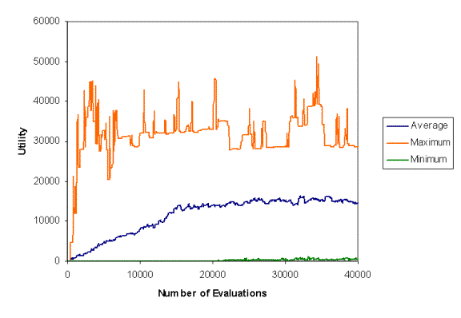
The average was of about 15,000 was unexpected so the individual graphs were investigated to ascertain what the program was doing.
It was discovered that in five out of ten runs for this type of mutation that the system went to around 65000 average with maximum around 130,000 and a minimum around 0. It was expected that the average should slowly climb close to the maximum as higher fitness individuals were created and then take over the population.

The other effects in this experiment were ignored because none of them seemed to be producing viable offspring. The explanation for this would hopefully be discovered whilst analysing the other more interesting runs.
Since this behaviour was very puzzling an investigation was made into it; this investigation involved trying to explain two phenomena within the system, the seemingly average distribution of utility values and why this distribution occurred.
The first question to be answered was what exactly was happening in the system to make it have an average fitness that was the mean of the entire range and a low min and high max. There were two explanations put forward.
That it was somehow putting a random number in the output. This could have been by any method; it should give a smooth range between the maximum and the minimum.

The other option was that it was somehow adding a big new number each time and looping round. Because larger numbers than the size of the array get truncated to the size of the array the programs could be adding a large number to the output area, this would create an average around the centre point of the range and minimums and maximums around the extremes. However this should have a different distribution to the random distribution, with more individuals both at the high end and the low end (offspring of the high individuals) giving a different range to the output.

In order to investigate this range a single run was taken and the population’s fitness was sampled for all the evaluations times between 16440 and 19990 iterations and the numbers collected into bins with a utility range of 1050. The graph below shows the amount of the utilities within the ranges and during that time.

Figure 2. Looking at distribution
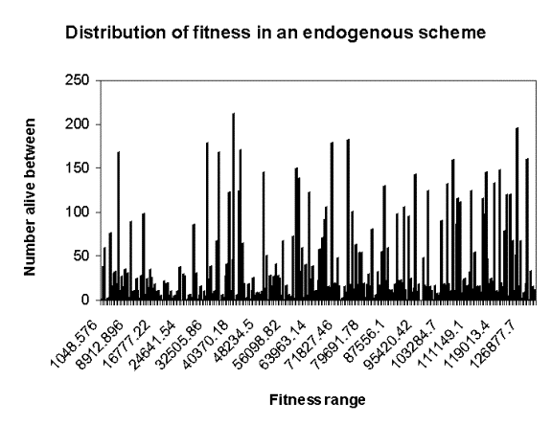
This shows roughly even distribution suggesting the output is somehow random rather than looping. Because this is taken over a large number of fitness evaluations, large spikes suggest longer-lived individuals that have been evaluated lots of times. This suggests that the individuals do not change their fitness over their lifetime, which was a possibility.

So if the programs had evolved to do this why had they stopped at solely putting a random number, why hadn’t the evolution continued to improve the fitness, for example by stopping putting a random number after a high value has been put in. Again there were a few options as to why this may be happening. The first was because the offspring had stopped mutating and so the population stabilised in the state it was in. The other option was that after the space in the virtual machine was filled the offspring couldn’t survive the time between when they were created and evaluated. This would mean that the older individuals could persist indefinitely stifling innovation from the younger individuals. In order to make sure this wasn’t happening a mechanism was introduced that protected the offspring until they had been evaluated. This was a just a check when an individual was to be killed that it had been evaluated, if it hadn’t then it wasn’t killed.

Figure 3. Protected Offspring
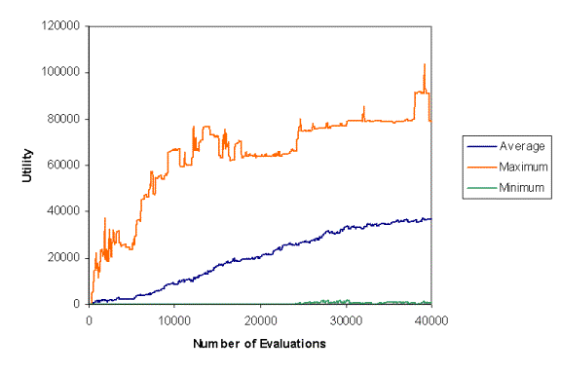
As the above graph shows the program acts very similarly to the first experiment. And looking at the individual runs shows that the main difference between the two experiments is that more of the runs went to the average around 65,000 state. This suggests that if there is any advantage to protecting the offspring it is not in the later stages, where the states all seem to stop, but is earlier on in a run.

Whilst performing the above experiments it was determined that there might be some undeterminable fault with the system that caused it to go to this state. What was needed was a prediction concerning the system that could be tested. It was thought that this evolutionary system should not go from a higher average fitness to a lower average fitness. So in order to see if the program would go to this state no matter what the starting value, i.e. would the system lose average fitness if the starting value was higher than 65,000, a series of experiments were done with the starting fitness above 65,000. If the system decreased in fitness then there was something wrong with the system as a less fit individual should not be able to invade, and if the output was somehow random then a less fit individual on average should not be able to invade either as more often than not an individual with 70,000 would overwrite a random individual. So the ten runs were repeated with 70,000 in the output to start with. In this case not much happened so an average graph is indicative of each individual run.

Figure 4
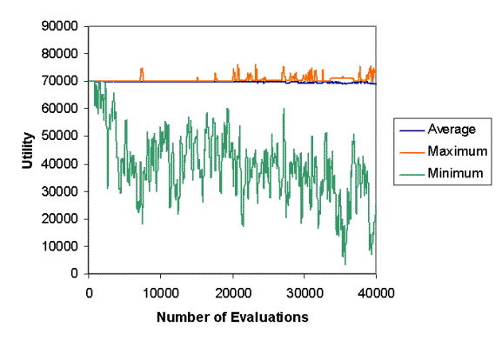

As can be seen the average of the averages barely moves away from the 70,000 mark. This suggests that as well as being unable to move into the random state because of evolutionary pressure there is no better state to this that can be reached by the mutation that is used. The minimum is quite low as there are often unviable offspring that have strange fitness levels, which drags down the average fitness.

Looking at an individual
In order to resolve exactly what was going on, individuals were taken from the virtual machine and inspected. It was found that for two separate runs and two individuals they had both stopped the mutation of the offspring and had found different ways of putting the address of the owner in the output location.
Code Snippet 1.
Original | Run 1 | Run 2
70: 7 :Action add  71: 6  72: 11  73: 23  74: 75 | 70: 2 :Action getOwner  71: 6  72: 11  73: 23  74: 75 | 70: 7 :Action add  71: 6  72: 8  73: 23  74: 75

As can be seen in run 1 the action has been changed to getOwner. This means that the owner of 11 (being the location of the program) is placed in location 6 being the output location. This is only a single change and would probably have been caused by the And-ing mutation. This mutation that causes the output to be the location of the program would explain the distribution. This is because the location of an individual is essentially random, it is chosen randomly, and is static throughout the lifetime of the individual. The second run also shows the same sort of behaviour but by a different method, it uses information stored in 8, which is where the location of the owner is stored to access the position in memory where the program is.

Code Snippet 2.
Original | Run 1 | Run 2
100: 9 :Action and  101: 93  102: 93  103: 97  104: 105  105: 9 :Action and  106: 92  107: 92  108: 97  109: 110  110: 7 :Action add  111: 98  112: 92  113: 22  114: 115  115: 105 :Action and  116: 98  117: 98  118: 93  119: 120 | 100: 9 :Action and  101: 93  102: 93  103: 0  104: 0  105: 0 :Action setOwner  106: 0  107: 0  108: 97  109: 110  110: 7 :Action add  111: 98  112: 92  113: 22  114: 115  115: 105 :Action and  116: 98  117: 98  118: 93  119: 120 | 100: 9 :Action and  101: 93  102: 93  103: 97  104: 105  105: 9 :Action and  106: 92  107: 92  108: 97  109: 110  110: 6 :Action lessThan  111: 98  112: 92  113: 22  114: 115  115: 105 :Action and  116: 98  117: 98  118: 93  119: 120

In the first run the mutation was stopped by a sequence of zeros being placed. Quite how this was changed is a mystery; it is possible that they were all changed by mutation, but not likely. It is more likely to have been a copying error of sorts. However the affect of the change is to stop mutation, this is because the Action that was changed to setOwner was part of the section that chose the location to mutate. The mutation that occurred meant that the part chosen was pretty much random throughout the memory of the machine instead of restricted to the offspring. This reduced the effective mutation rate immensely.
In run 2 the mutation completely stopped because the location was disrupted in a more dramatic fashion with the random number between 0 and 127 not being added to the base location of the offspring to make the output location. This meant a single location relative to the owner was And-ed every time and it was not a vital location.

Discussion of Initial Experiments
What happened in the system in these experiments was interesting in that it showed the transition from imperfect replicators to perfect replicators. Also it showed the many ways this could happen and how hard it was to monitor. That one of the positive mutations accessed another bit of memory of the individuals helps to justify the open way the system was created, which meant not having hidden registers, a slight difference from Tierra.
Because the system seems to stop mutating quickly it is hard to see whether the evolutionary aspect of the program is working correctly. For example is the program always propagating fitter individuals that arise in the system?
In order to answer these questions a more predictable system needs to be investigated. The unpredictability in this system is due partly to the fact any section of code can be altered including that section itself.

5.3 Test of other types of Mutation
As the endogenous mutation seemed to not be suitable for investigating the system, it was decided to investigate other more stable forms of mutation and compare the results. These were a restricted form of endogenous mutation, exogenous mutation that could change all parts of the offspring and a restricted form of exogenous mutation. The restricted forms, both endogenous and exogenous, of mutation change the output location of the offspring rather than all the locations of the offspring. Although these mutation schemes are not part of an investigation into no fixed biased search they help in clarifying the properties of the system created thus far and pointing out any weaknesses within the system.

Endogenous restricted
The mutation is restricted to working on the output location within this regime; the amount of change is done in an adaptive fashion. The parent flips the output bits of the offspring with a certain probability. The easiest way to implement this probability within the virtual machine was to XOR the output with a random number. A random number has the probability of flipping half the bits of a number, this is because, on average, half the bits of a random number are 0 and the other half are 1. In order to control the amount of bits that are flipped the random number is And-ed with another random number. And-ing the number with another that only has on average half of the bits as one, reduces the number of bits set in the number by half. In this fashion the number is reduced within a for loop. This number is then XOR-ed with the output to get the new number. The number of times the loop is executed is changed, by selecting another number between 0-31 on average half of the time that the individual starts to mutate its offspring.

Because of the time taken to perform the mutation within the endogenous mutation the output occasionally does not have time to be output. In order to solve this problem the output instruction was taken out of the replication and given another loop of it’s own.

Header
Replication Loop
Mutation
Finish Replication
Output Loop

Again 10 runs were performed and the results are below.
Figure 5
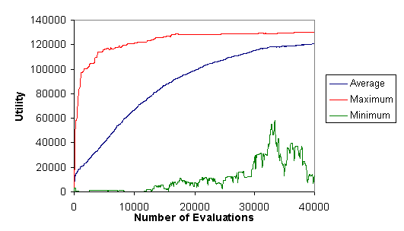
This is a more expected graph with the average of the utility increasing to an average of 120724 over the 10 runs. It shows that there is nothing intrinsically wrong with the utility function and the other selection mechanisms within the system. The probable reason that the average does not reach closer to the maximum is the way the mutation changes. Since the mutation changes on average half the times the program replicates it is not very heritable and so evolution cannot work on it very well.

Exogenous unrestricted
In order to see what the system performed like under different utility regimes I implemented exogenous mutation. So that it would be more successful at flipping the output memory area I changed it so that it flipped a random bit of the block to be copied with a probability of 1 in a 100 copy actions.

Figure 6.
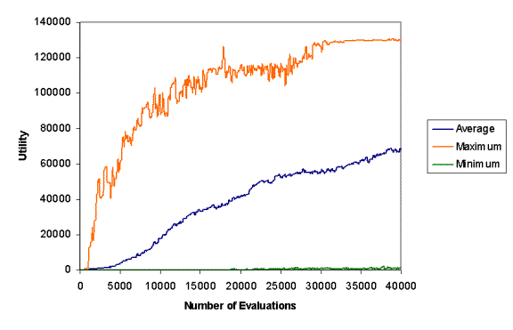
However starting with 100 in the output the system seemed to always eventually go to the situation that happened with the original endogenous mutation that is putting the location of the owner in the output. This gives an average utility of around 65000, however it is a local minima because if you disrupt the part of the program that puts the location in the output it is less fit and single bit flips cannot create more complex changes in the program. You would need to alter the output at the same time to be above 65000 in order to escape the minima. The above graph also lends evidence to the fact that the endogenous mutation stopped mutating as all the runs in this system went to the random state, because not all of the endogenous runs went to this state, suggesting that the mutation had stopped. So in order to test the exogenous mutation to see if it can find other ways to states apart from the random state, the system was tested with a program with utility of 70000.

For an average of ten runs, after 40,000 fitness evaluations, the mean average fitness was 73673 up 3600 thousand from the start. The lack of viable individuals may stop the evolutionary process from being efficient as there will be fewer individuals for mutations.
Figure 7.
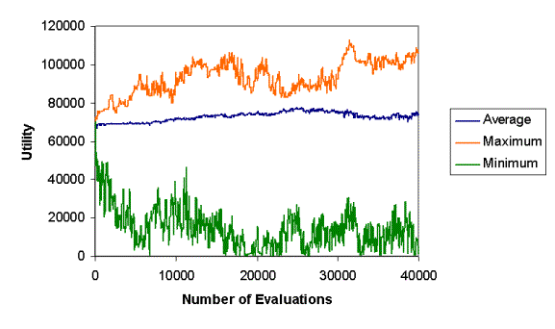

As can be seen the maximum the average reached was not very high and also dipped below the maximum found. This unusual situation suggested something strange was going on, as this should be unlikely to happen within in an evolutionary system. In order to investigate this a variety of statistics were looked at. One of them that may explain what happens is the number of individuals that are alive at any point. Alive individuals are those that have been evaluated at any point. Below are a graph of number alive verses iterations with no mutation and exogenous mutation.
Figure 8. Example of Normal number alive with no exogenous mutation
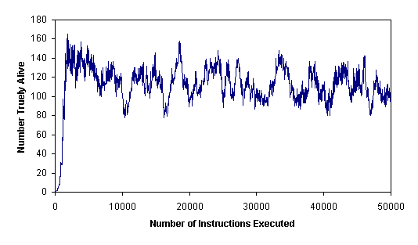
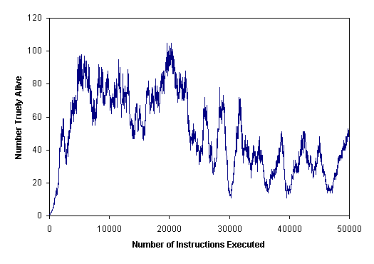
Figure 9. Example of Number alive with 1 in 100 chance of a single bit flip each time a block is copied
As you can see in comparison there are fewer alive and also there are cycles within the system of population. These cycles cause the number alive to drop dangerously below 20 in some cases. This is probably because fewer offspring are viable due to mutation and some of those unviable offspring overwrite viable individuals, causing a drop in total viable individuals. One of the runs went to a static phase where there was no more reproduction, due to this cycling. A comparison of the average fitness and number alive can be seen below for the case. It can be seen there is some correlation between decreases in the number alive and the average utility.
Figure 10.
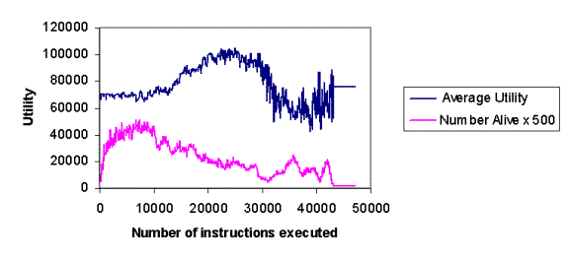

Also the number alive at the start is generally higher than the number alive at the end, this maybe to do with cumulative mutation that is the rate of mutation is so high that selection cannot remove the negative mutations within the system.

Why is this mutation so bad?
It is likely to kill the offspring. Also with a length of 20 blocks a creature will get on average one mutation. The chance this mutation is on the correct section of a block is 1/100, the chance at the start it will flip a 0 is 8/17, so the chance when copying that a better mutant will be available to the gene pool is 0.0047. Include the chance that the offspring will not be viable because of another mutation, poor placement or being over written and the chance of a viable better offspring drops quite low. This means a long time will be waited for better individuals to come along. Also the chance of getting the best mutation drops to 0.0005 because a mutation is more likely to flip another, bit making a worse individual.

Exogenous restricted
This restricted mutation only works on the output of the program. It flips a single bit of the output every time the output is copied. This is done in the virtual machine itself, so cannot be changed by any copying errors.
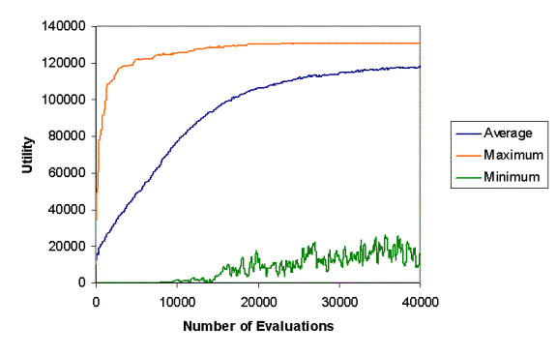
Figure 11.

The Average value of the average utility after 40,000 evaluations was 117926, which was less than endogenous restricted otherwise it is very similar to the endogenous self-adaptive. The lower average in the end is probably due to the fact that mutation cannot stop or reduce in the exogenous case and so less fit individuals will be constantly created in this scheme.

Discussion of results
Comparing the four different results shows that variation when correctly applied can result in a steady increase in the average utility. However as the restricted schemes have no chance of altering anything else apart from the output it is very unlikely that they can change the way it varies its offspring. This means its bias is fixed by a certain quantity. So although the system works evolutionarily, the current programs are a long way from no fixed bias search if it is possible.

A two tailed T-test between the restricted endogenous and restricted exogenous was significant to 90 percent suggesting that the endogenous is a better than the exogenous variation. This might be because the variation in the endogenous can be changed and reduced allowing the programs to reduce the number of bad offspring they have compared to exogenous mutation.

5.3 Various Different utility schemes

Having demonstrated that the system can evolve solutions in a predictable fashion it was decided to investigate parts of the system to see how the system reacted to different conditions and variations within the system. This was mainly because the next stage of the search for meta-variation seemed out of the reach of this project. Different conditions were used with the restricted endogenous system, because it was the most successful system.
These different conditions were; not having to pay energy for executing an action, not having their energy reduced once they have overwritten another owner and a combination of the two.
Figure 12.
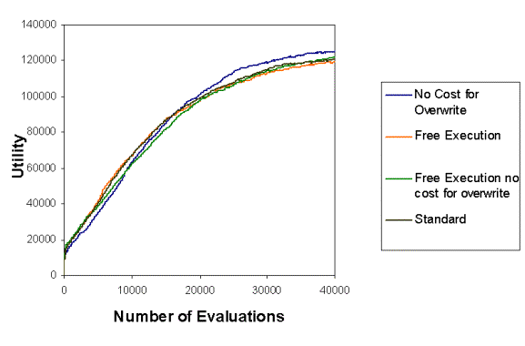
The only experiment that that was significantly different with 95% probability compared to the standard run was the no cost for overwrite run. This was probably due to the fact that the survival advantage for having a higher utility was amplified by not having to pay for overwriting another individual. However the combination of this feature with not having to pay for executing an instruction seems to lessen the effect of this advantage, perhaps by favouring less fit individuals. It is worth noting that the advantage given to the fitter individuals may not be advantageous in all situations as it may stifle innovation and change within the system.

6.0 Conclusions

Although great steps towards a different way of computing haven’t been made with this work, I have laid the foundations of a system and the experiments that will help me to evaluate whether this is a useful direction to go in. A promising thing that happened during my experiments was a the discovery of a better means of getting good average fitness by making the location that the program was at the output. So a better form of change was found, however the program quickly stopped looking for other better programs and they became perfect replicators.

There has been no great advance on the evolutionary side of things although very few of the experiments were done towards the idea of no fixed bias, as the experiments to determine if the virtual machine functioned correctly and some investigation into the selection pressure took up the majority of the time within the dissertation.

A question I ask myself, was it worth it to build a new virtual machine while the virtual machines for other A-Life systems are available? While everything that has been done in this project could have been done in another system, Tierra for example, there are a few features that are interesting in there own right. For example the system shows a Tierra like system that uses competition for space rather than a fixed reaper like entity for deciding who should survive. This distributed method of selection might have advantages if it becomes prohibitive to constantly monitor all the individuals as it is in massively parallel systems. Other aspects of the virtual machine such as the possibility for hierarchies, energy giving and partnerships, understandably haven’t had any attention in this project, yet I hope that in the future they will allow novel behaviour to be seen in the system.

The central pillar of this endeavour, that the variation can vary the method of variation, has shown itself to be a thorny problem. If the variation is itself too stupid it will most likely stop variation and bring the system to an evolutionary halt. However one promising metaphor to investigate uncovered in light of this project is that trying to create a program that can alter itself is akin to writing something that can read and write in a language, in this case a programming language. This metaphor is useful because when a program modifies its offspring it is in affect reading its offspring to decide where and how to modify and using that information to write a bit of code that fits in with the syntax and grammar of the programming language. It would be interesting to see how a program that has rudimentary computing language skills will be able to change itself through evolution. If this approach does not give the individuals the ability to alter the code of it’s offspring and increase their fitness, this venture will run into the same problem as the chatterbots. This problem is that in order to make something write coherently about the world it must know a lot of background knowledge about the world. If this were also necessary for the programs writing computer code then the automatic programming wouldn’t be very automatic. In order to go in this direction the knowledge of which symbols to use, which arrangements of symbols to use and which grammar to use can be progressively introduced into the system in order to see how these things work. However the current virtual machine is very slow and would be quite small compared to how complex these programs would have to be in order to do what I suggest, so significant work would need to be done optimising the program.

Modelling this system in order to verify the results is also quite hard as there is no fixed population size. Also there is no way of knowing short of executing the system how many of the new offspring created will become viable replicators.

Philosophically speaking I think the ideas presented in this dissertation are sound, and I have not yet found reason to revise them in light of the experiments done to date. However there are still concerns as to whether such a thing as a stable no fixed bias search can exist or whether there is always a likelihood of getting stuck.

References
Adami, C & Brown, C. T. (1995) “Evolutionary Learning in the 2D Artificial Life System Avida”. In Artifcial Life IV. Cambridge: MIT Press, pp. 377-381
Bateson, G, (1972) “Steps to an Ecology of Mind” Jason Aronson
Bedau, M.A., Snyder, E., Titus Brown, C., and Packard N. (1997) “A comparison of evolutionary activity in artificial evolving systems and in the biosphere. In P. Husbands and I. Harvey (Eds.), Fourth European conference on artficial life. (pp. 125-134). Cambridge: MIT Press.
Beyer, H.G. (1995) “Toward a theory of evolution strategies: Self-adaptation”. Evolutionary Computation, 3(3):311--347,
Brooks, R.A. (2001), “The Relationship Between Matter and Life”, Nature, Vol. 409, January 18, pp. 409–411. (Invited)
Brooks, R.A., C. Breazeal (Ferrell), R. Irie, C. Kemp, M. Marjanovic, B. Scassellati and M. Williamson (1998), “Alternate Essences of Intelligence”, Proceedings of the Fifteenth National Conference on Artificial Intelligence (AAAI-98), Madison, Wisconsin, , pp. 961--976.
Channon, A. and Damper, R. (1998). “Evolving novel behaviors via natural selection”. In Adami, C., Belew, R., Kitano, H., and Taylor, C., editors, Proceedings of "Artificial Life VI", Los Angeles, June 26-29, 1998. MIT Press
Cowling, P., Kendall, G., and Soubeiga, E. (2001) “A parameter-free hyperheuristic for scheduling a sales summit.”, Proceedings of the 4th Metaheuristic International Conference, MIC 2001, 127-131.
Culberson, J (1996) “On the futility of blind search”, Technical Report TR-18, University of Alberta
Darwin, C (1968) “The Origin of Species by Means of Natural Selection”. Penguin Books
Dawkins, R (1982) “The Extended Phenotype: The long reach of the Gene”. Oxford: Oxford University Press
Dawkins, R (1989) “The evolution of evolvability,” Proc. of Artificial Life: The Quest for a New Creation, Santa Fe, U.S.A.
Fogel, L., Owens, A. and Walsh, M. (1966), “Artificial Intelligence through Simulated Evolution”, Wiley, New York.
Goertzel, B www.realai.net
Gregory, Richard L. (1981) “Mind in Science” Weidefield and Nicolson. London
Holland, J.H. (1992) “Adaptation in Natural and Artificial Systems”. Cambridge MA, MIT Press
Hurst, J. & Bull, L. (2000) Self-Adaptation in Learning Classifier Systems. UWELCSG00-001.
Kantschik, W., Banzhaf, W. (2001) "Linear-Tree GP and Its Comparison with Other GP Structures". EuroGP 2001: 302-312
Mladenovic N. and Hansen, P. (2001)“Variable Neighborhood Search : Principles and Applications.” Euopean J. of Oper. Res., 130. 449-467
Minsky, M (1986) “The society of mind”, London, New York, Simon & Schuster
Papert http://web.mit.edu/newsoffice/tt/2002/jul17/papert.html
Rasmussen, et al. (1990) “The Coreworld: Emergence and Evolution of Cooperative Structures in a Computational Chemistry”, FORREST90, 111-134.
Ray, T. S. (1991) "An approach to the synthesis of life." in ALIFE II, 371--408.
Rechenberg, I. (1973) “Evolutionsstrategie: Optimierung technischer Systeme nach
Prinzipien der biologischen Evolution.” Frommann-Holzboog, Stuttgart.
Rudolph, G. (2001)"Self-adaptive mutations may lead to premature convergence" Aug IEEE Transactions on Evolutionary Computation, vol 5, Issue 4, 410-414.
Smith J.E. (2002) "Co-Evolution of Memetic Algorithms for Protein Structure Prediction". In Hart, Krasnogor and Smith (eds) Proceedings of the Third International Workshop on Memetic Algorithms (to appear 2003).
Smith J.E. (to appear 2003) “Parameter Perturbation Mechanisms in Binary Coded Gas with Self-Adaptive Mutation Rate”, In Rowe Poli and DeJong (eds) Foundations of Genetic Algorithms 7, Morgan Kaufmann
Spector, L. 2001. Autoconstructive Evolution: Push, PushGP, and Pushpop. In Spector, L., E. Goodman, A. Wu, W.B. Langdon, H.-M. Voigt, M. Gen, S. Sen, M. Dorigo, S. Pezeshk, M. Garzon, and E. Burke, editors, Proceedings of the Genetic and Evolutionary Computation Conference, GECCO-2001, pp. 137-146. San Francisco, CA: Morgan Kaufmann Publishers
Schwefel, H.-P. (1974) “Adaptive Mechanismen in der biologischen Evolution und ihr Einfluβ auf die Evolutionsgeschwindigkeit” Technical Report, Technical University of Berlin. Abschluβbericht zum DEG- Vorhaben Re 215/2
Schwefel, H.-P(1995). “Evolution and Optimum Seeking” New York, NY: Wiley.
Yudowsky, E www.singitnst.org

Appendix I

Definitions

Utility: a measure of worth equivalent to fitness in evolutionary computation, but because the utility is not directly equivalent to the number that will be passed on to the next generation, utility is used in stead. In order to be worthwhile those with more utility should be more likely to survive than the equivalent program with less utility.

Utility function: a function that distributes utility based on some actions of the programs

Virtual Machine: the machine which holds the programs that evolve

Program: used in this piece as a short hand for a program that replicates and evolves in some manner.

Owner: 1) The area that owns another area where all areas owned by the same owner can perform any action on each other, it also stores energy and that energy is removed if any of the areas owned by it perform an action.

Owner: 2) The program that owns the other program and can do whatever it like with that program, indicated by the owner being set in the owner area of that program. This does not allow the owned program to remove energy from the owner however.

Partner: The program indicated by

Economy/Ecology of the mind: The concept of the mind as related to economies and ecologies. Derived from work on Learning classifier systems but more free like the real economy/ecology in what can happen inside it.

Appendix II

Assembler syntax
One instruction is 5 lines longs with associated operands and modifiers

Any of these lines can have a label in the following style

:LABEL restOfLine

The colon is needed to denote a label, note that label checking is not performed so it is up to the user to make sure there are no duplicate labels in there code. When a label is found in the code it is substituted with the correct line number.

Line 1 Action line

(Number or ActionString) [abs]

The abs denotes the special form of addressing to be used in the operand lines where denoted is absolute rather than the default of indirect.

Lines 2-4 Operand line
These are all similar and therefore treated the same way

[ind](Number or Label)

ind indicates that a special form of addressing be used on this address, what exactly this addressing is depends upon whether abs was set in the action line. Normally it is indirect addressing.

Line 5 Next action to be performed line
(next or Label)

next indicates that the next line number should be used to jump to after completion of this action

An example is below

:loop setOwner
ind new
ind rnda
0
next

Appendix III

Reference for Virtual Machine Instructions

Addressing
This uses the four bits from address bit 5 to bit 8. Bits 5-7 specify if a special form of addressing other than the standard relative for the destination and source areas. Bit 8 specifies what type of address is used when a bit is set in bits 5-7. This can either be for 0 indirect addressing or absolute addressing if one is set.

Name | Number | Number of parameters | Access Needed  Dest first  (3 wrx 2 rx 1 x) | Description
SetOwner | 0 | 2 | 330 | This sets the owner of the destination area to the area specified by src1 and makes src1 an owner if it is not already.
transEnergy | 1 | 3 | 301 | Gives the amount of energy specified by src2 from the destination area to the area specified by src2
GetOwner | 2 | 2 | 300 | The owner of src1 is put in to the destination (note no access is needed to find the owner, this is to prevent the owners from completely hiding there owners so that they can differentiate between them)
jmpEqZero | 3 | 2 | 300 | If the dest is equal to zero the next number is set to the address in src1 else it is set to src2
Equals | 4 | 3 | 311 | If src1 equals src2 then 1 is put at the destination, otherwise 0.
LessThan | 5 | 3 | 311 | If src1 is less than src2 then 1 is put at the destination, otherwise 0
Add | 6 | 3 | 311 | Add the two numbers together and puts them in the destination.
Not | 7 | 3 | 311 | Inverts the bits of the src and puts it in the destination
And | 8 | 3 | 311 | Same as add but bitwise ands
Or | 9 | 3 | 311 | Same as add but bitwise or
Xor | 10 | 3 | 311 | Same as add but bitwise xor
getCounter | 11 | 1 | 300 | Gets the counter of the virtual machine and puts it in the destination
Branch | 12 | 1 | 200 | Creates a new executing thread at the destination
Rnd | 13 | 1 | 300 | Puts a new random number into the destination area
GetArea | 14 | 2 | 310 | Gets the area number of section of an area and places it in the destination.
Mod | 15 | 3 | 311 | Same as add but mod
Copy | 16 | 2 | 310 | Copies all the sections of an area to another area
Newplace | 17 | 1 | 300 | Gets the next number in the series which changes depending upon the
Ins | 18 | 2 | 330 | Puts the destination area after the area specified by src1 moving the pointers around correctly.
pickFromList | 19 | 2 | 310 | Looks at a linked list of numbers specified by and picks one of them with equal probability. The list ends when the pointer in an area points points to previous member of the list or to an area that cannot be accessed
jmpChance | 20 | 3 | 100 | This looks at the number in the destination and if it is greater than a random number it jumps to the destination specified by src1 otherwise it jumps to the destination specified by src2
Noact | 21 | 0 | 000

Table 1

I suggest that contrary to Brooks et al. (1998) we are general problem solvers. However I would like to qualify this by saying that we are weak general problem solvers. By this I mean that given the correct information and enough time we can learn to solve any problem. This I hold as different from the strong position, which I think that Brooks et al. were trying to argue against. Which is, if I gather correctly, that humans are applying the same solving process to any problem. However apart from biological evolution there are no other real world problem solvers of similar creativity with which to compare us to. For speed of finding answers we seem to be better than evolution although there are still some things we struggle with, but nothing that seem insurmountable.
This is not the ultimate form of a No Fixed bias system. Since by the definition of no fixed bias it is able to change it’s entire source code it can take any form and it will probably take different forms in different environments. The next section deals with ?the possibility of forming other levels of search that could shape how the program learns.

